3.1. Civil Engineering

3.1.1. Definition of the problem
The capstone project could represent each of the six subareas: construction material, geotechnical engineering, structural engineering, earthquake engineering, transportation engineering, and water resources. Describe the problem statement and general framework of your study using the summary of your project given on the course website by your advisor. State your contribution to solving the issues regarding the regular meeting discussions between you and your supervisor. Use flow charts (e.g. Fig.6), figures, and drawings for clarifying, visualizing the problem statement and workflow together with the targeted achievements of the project. Address the following features,

- Meet the specific engineering needs of the society and characterize the essential features of the materials, technology, or built environment by adding value to the current state of practice.
- Design criteria and evaluation process
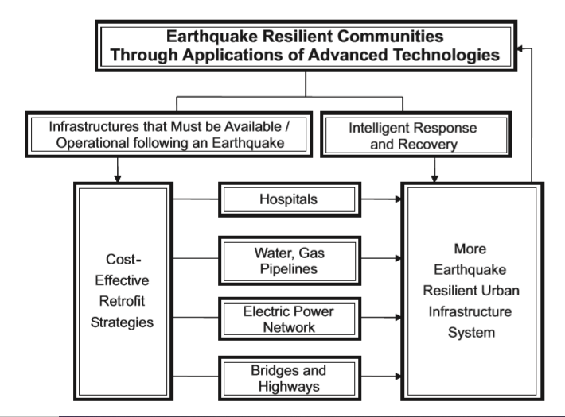
Figure 7. Assessment procedure towards community resilience (Huang et. al., 2009).

3.1.2. Overview of technologies and method of analysis
Conduct a comprehensive literature survey to introduce the available method of analysis and emerging technologies in your study. Refer to the critical studies and describe the missing points of existing guidelines, systematically. This can include textbooks, handbooks, technical papers, technical reports, web sources and regulations. A summary of similar designs, procedures, or techniques that already exist should be discussed together with the alternative concepts that you considered. Emphasize the contribution of your work in developing conceptual approaches to the problem statement. Indicate whenever the design process was supported by previous university coursework.

3.1.3. Standards and limitations
Specify well-known standards used for the design, analysis, and quality control of construction materials and/or structural systems. Briefly explain the relevant sections of standards and their limitations concerning your problem statement. Refer to design provisions several aspects such as structural safety, environmental effects, social effects, financial benefits. Discuss the strengths and weaknesses of alternative concepts in accordance with the standard provisions and explain which design you finally arrived at and why.

3.1.4. Description of materials and structural features
Discuss the functional features and performance requirements for materials, structural systems, and applied procedures. Get involved in the improvement or optimization of a design in sophisticated engineering design challenges. Provide a table, graphs, and design details of structural systems that summarizes the material characteristics and mechanical properties.

3.1.5. Applied procedures for testing and/or numerical simulation
Define measurement methods, required resources, tools, and facilities and disclose any special external aid you have received, such as outsourcing of construction or manufacturing process of innovative materials. Explain the specification of test equipment (Fig.7) and tools like object-oriented computer programs. If you have been using tools for the numerical simulation of the problem, describe method of analysis, modelling technique and appropriate analytical formulation in your study. Express the detailed work plan and analysis procedures.
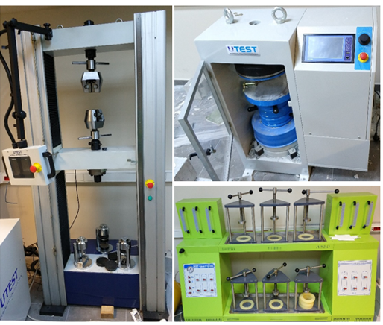
Figure 8. Testing equipment used for determining the material properties.

The test procedures created during the development phase is executed in accordance with the test plan, strictly following the verification activity. Test plan, execution, and results should be documented and maintained as a part of capstone project records.

3.1.6. Quantification for the verification and validation
Quantify the performance metrics and demonstrate the consistency and completeness of the design concerning the user needs. Validate product or structural forms against the user requirements. Describe the possible validation and verification schemes with the design team to identify issues in the final plan. It is essential to document the changes and get a proper approval process. Analyzing the design can be done, such as mathematical modeling, a simulation through physical tests that can recreate the required functionality. Tests are performed on the final design that validates the ability of the generated system to operate as per the specified design. Validation of end products or the design will point out the difference between the generated models and how it is expected to work in the capstone project proposals. The difference between the outcomes and user needs must be well-defined in the report. Every step of the validation and verification process must be documented in detail, and the validation process adequately proves that the design meets the user requirements.

3.1.7. Evaluation of results
Apply a transparent evaluation process for test results and numerical simulations. Compare analysis results with the established goals of Capstone projects and listed performance items. Consider the performance items prescribed by code provisions along with those selected concurrently by the Capstone team to offer improvement and optimization. Determine the successes and failures of the project through a decision variable. Comment on the outreach of the project and the possibility of promoting structural technologies, structural design techniques, advanced materials, and new structural systems to meet performance requirements in future studies.

